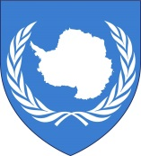 | The Antarctic Micronational Union  Unites Antarctic micronations since 2008

INTERVIEW NEW MEMBERS

Introduction
Dear micronationalist,

Your request the membership of the Antarctic Micronational Union.

Since the foundation of the Antarctic Micronational Union on December 6th, 2008 the AMU organizes Antarctic micronations and protects each other’s territories by register all territorial claims.
Before you request the AMU-membership: please check the official map of Antarctic micronational claims if your territory isn’t already claimed.

Before the AMU accepts your claim, we need some correct and truthful information. Please answer the questions and send this document back to mar@lostisland.org. Based on this document, the governments of the AMU members will decide whether they accept your claim and recognize your micronation.

Respectfully,
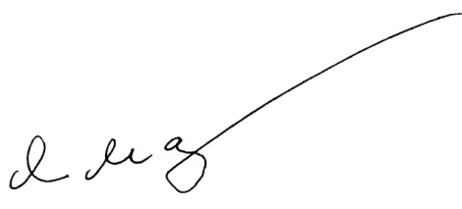
Administrative-General

Yaroslav Mar, President of the Federal Republic of Lostisland

General information
Name micronation:
Date of foundation:
Type of government:
Head of State:
Minister of Foreign Affairs:
Population:
Claims:
Country of origin:
Spoken languages:
1.
2.
3.
Currency:
Religion:
Official website:
Other websites:
1.
2.
3.

Images & photo’s
Flag and coat of arms:
Flag | Coat of arms

Map of claim:

Interview

What is your motivation for claiming territory on Antarctica?

Why did you start with micronationalism and what goals you want to achieve with your micronation?

How serious you take micronationalism?

What is your opinion toward micronational wars and are you currently involved in a micronational conflict?

Does your micronation have problems with some religions, races or sexual genders?

Do you agree with the conditions for diplomatic relations from the AMU Charter (see attachment)?

Date: year/ month/ day

